**Designing a Distributed Atm System**

ATMs have become an integral part of banking. It allows users or customers to perform basic banking transactions outside the banking hall such a viewing their account balance, transferring money from one account to another, depositing money as well as withdrawing. A distributed ATM system provides for efficient utilization of resources as well as secure environment for transacting.

There will be the main user interface presented as a screen to display a welcoming message and a login section for the customer. The customer/user will be authenticated based on the PIN for an account.

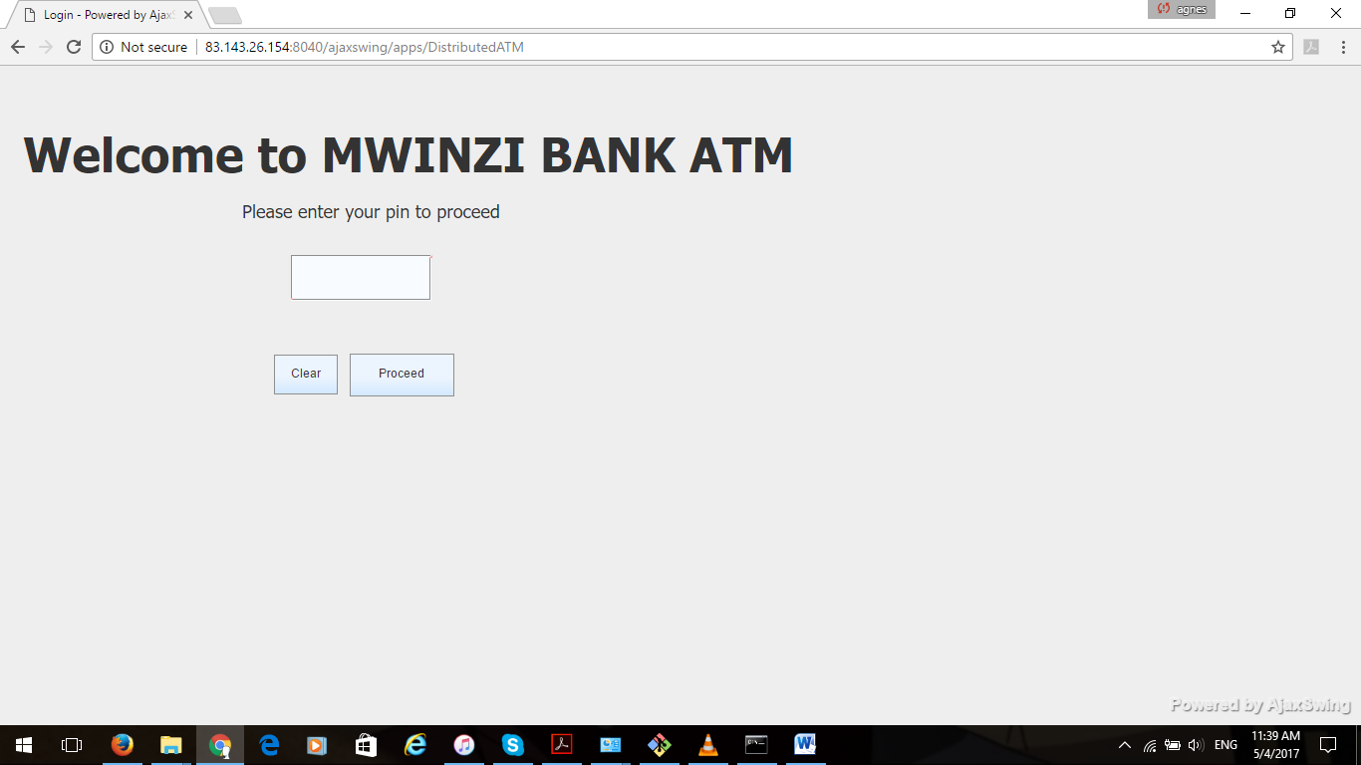

The credentials will be stored in a database that will contain the account number, a PIN and the account balance. The login PIN is set to **0000**.

The screen has a welcome message that prompts the user/customer to enter the PIN. Upon entering the correct PIN the main menu will be displayed. An incorrect PIN will display an error message and prompt the customer/user to key in the PIN again.

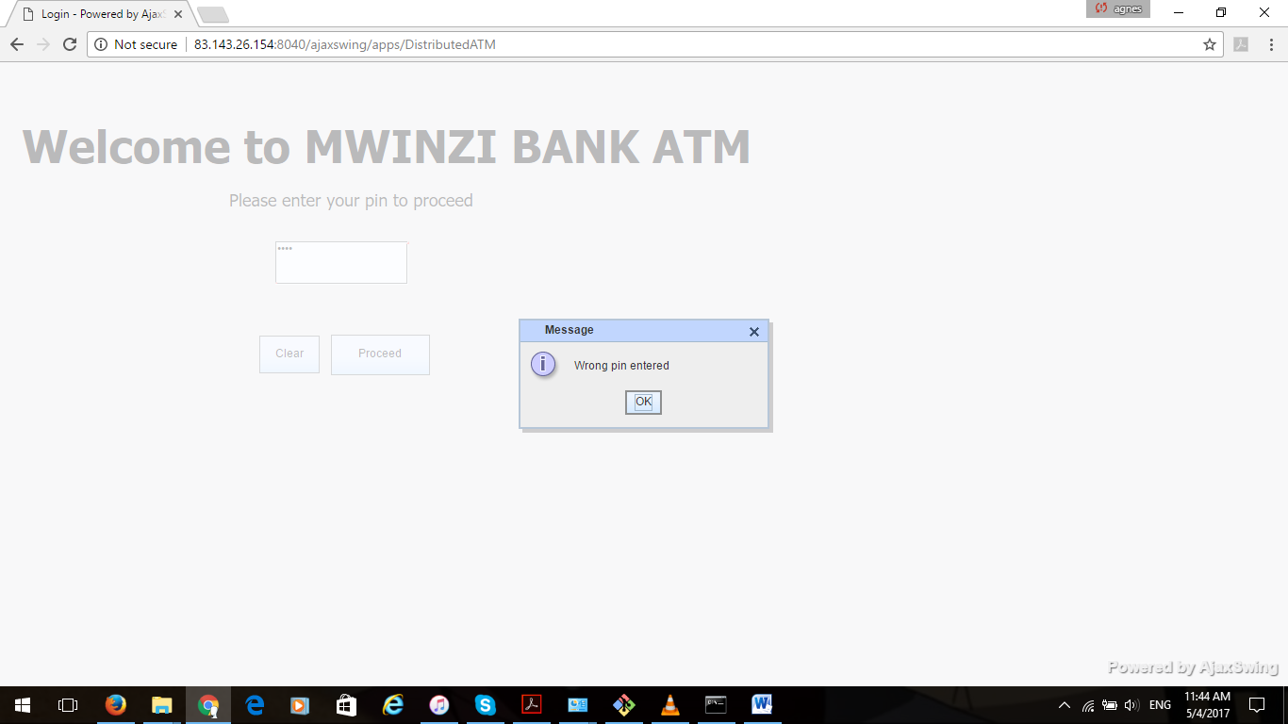

The main menu will display the following as captured below:

1. Check balannce
2. Withdraw cash
3. Deposit cash
4. Funds transfer
5. Log off

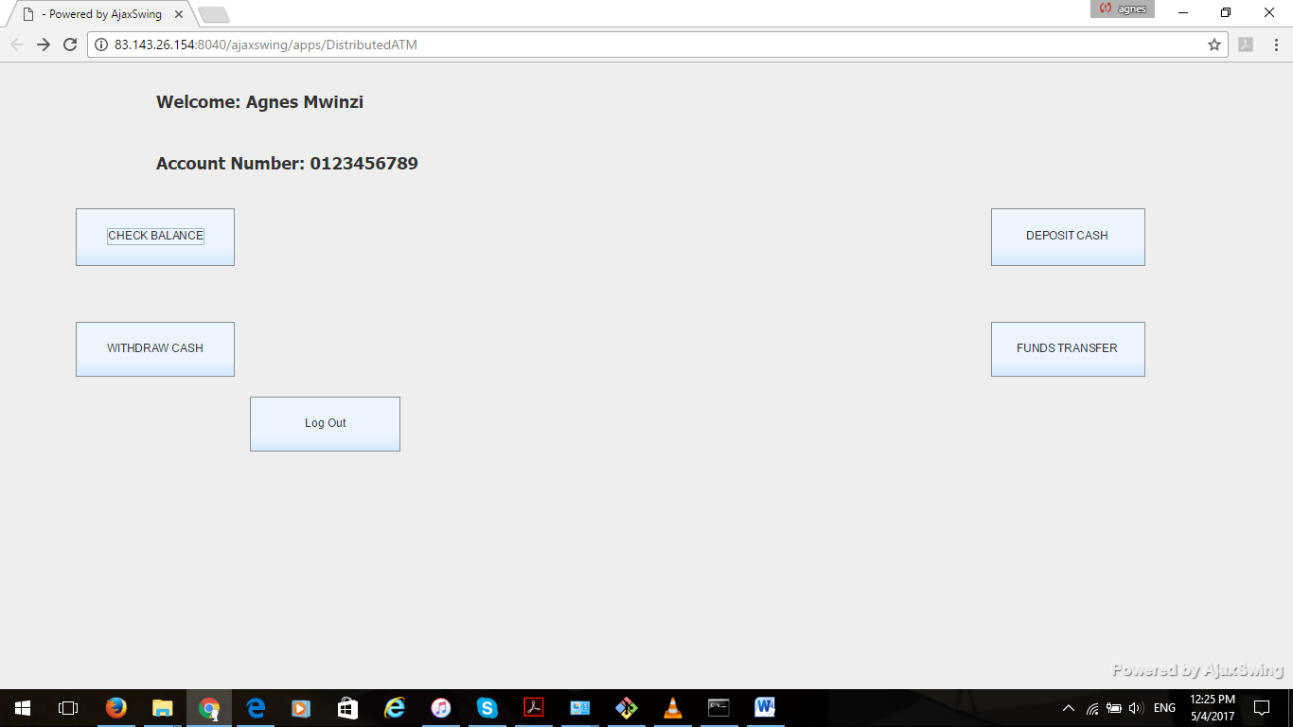

The customer/user chooses an action so as to continue.

Check Balance will display the customers account balance to be retrived from the Bank’s database.

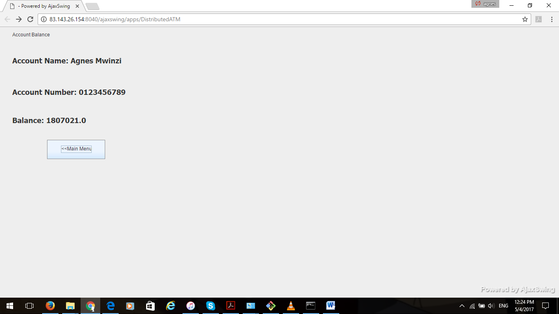

Withdraw cash will display the withdraw menu for the customer to input the amount they want to withdraw, then debit the account and dispense money.

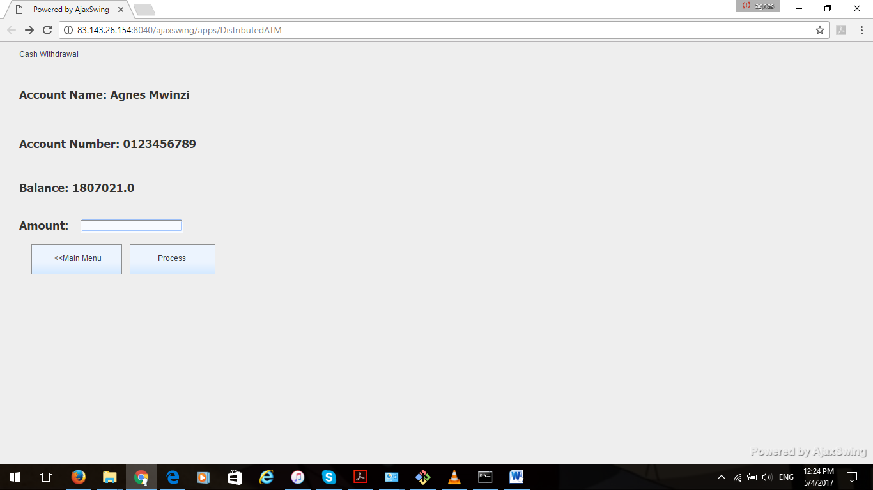

Deposit cash will prompt the customer to enter an amount they wat to deposit then accept the process.

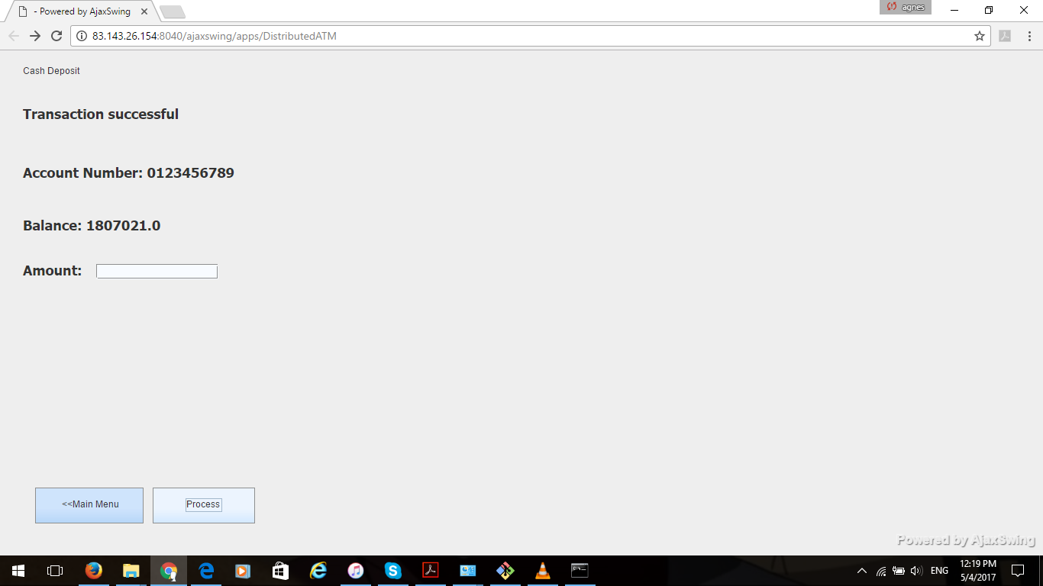

The customer can also tranfer money from the account to another existing internal account in the bank by keying the account number and the desired amount.

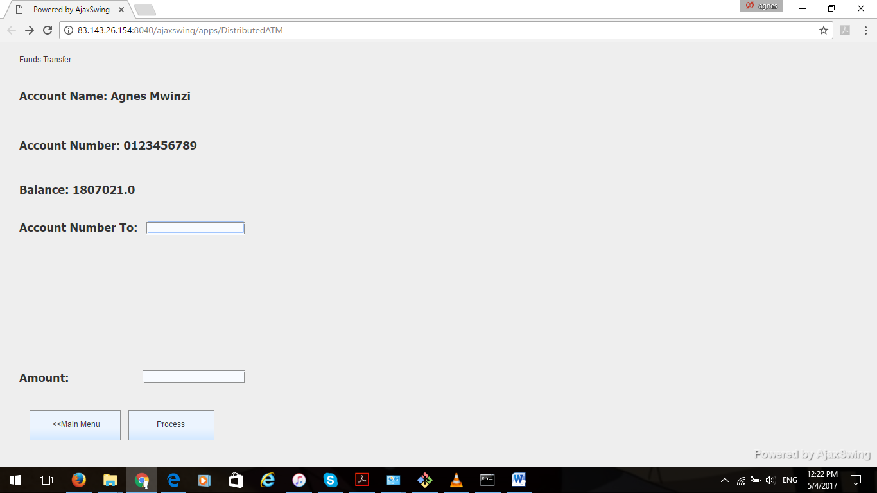

The Use Case Diagram



User/Customer